Example 3.20 (ST. PETERSBURG PARADOX):

* This paradox was noticed by a Swiss mathematician Daniel Bernoulli (1700-1782), a nephew of Jacob.
* It describes a gambling strategy that enables one to win any desired amount of money with probability 1.
* Isn’t it a very attractive strategy? It’s real, there is no cheating!
* ---
* Consider a game that can be played any number of times. Time is infinite.
* Rounds are independent, and each time your winning probability is p.
* The game doesn’t have to be favorable to you or even fair; this p can be any positive probability.
* For each round, you bet some amount x.
* In case of a success, you win x.
* If you lose a round, you lose x.
* ---
* The strategy is simple.
* Your initial bet is the amount that you desire to win eventually.
* Then, if you win a round, stop.
* If you lose a round, double your bet and continue.
* ==============================================================================
* Let the desired profit be $100. You want $100. The game will progress as follows:
  + Table

    Description automatically generated
* Sooner or later, the game will stop, and at this moment, your balance will be $100. Guaranteed!
* However, this is not what D. Bernoulli called a paradox.
* ---
* How many rounds should be played? Since each round is a Bernoulli trial (you either win or lose), the # of them, X, until the first win is a Geometric random variable with parameter p.
* ---
* Is the game endless? No, on the average, it will last E(X) = 1/p rounds.
* In a fair game with p = ½, one will need 2 rounds, on the average, to win the desired amount.
* In an “unfair” game, with p < ½, it will take longer to win, but still a finite number of rounds.
* For example, if p = 0.2, i.e., one win in 5 rounds, then on the average, one stops after 1/p = 5 rounds. This is not a paradox yet.
* ---
* Finally, how much money does one need to have in order to be able to follow this strategy?
* Let Y be the amount of the last bet.
* According to the strategy, Y = 100 . 2X-1
* It is a discrete random variable whose expectation equals:
  + Diagram, timeline

    Description automatically generated
* This is the St. Petersburg Paradox!
* A random variable that is always finite has an infinite expectation!
* Even when the game is fair offering a 50-50 chance to win, one has to be (on the average!) infinitely wealthy to follow this strategy.
* ---
* To the best of our knowledge, every casino has a limit on the maximum bet, making sure that gamblers cannot fully execute this St. Petersburg strategy.
* When such a limit is enforced, it can be proved theoretically that a winning strategy does not exist.
* ---
* Computing its variance, we run into a “surprise”,
  + 
* This variable does not have a finite variance!
* Its values are always finite, but its variance is infinity.
* In this regard, also see example 3.20 and St. Petersburg paradox on p.62.

Probability Density

For all continuous variables, the probability mass function (pmf) is always equal to 0,

P(x) = 0 for all x

As a result, the pmf doesn’t carry any information about a random variable.

Rather, we can use the cumulative distribution function (cdf) F(x). In the continuous case, it equals

F(x) = P{X <= x} = P{X < x}

These 2 expressions for F(x) differ by P{X = x} = P(x) = 0.

Assume, additionally, that F(x) has a derivative.

This is the case for all commonly used continuous distributions, but in general, it is not guaranteed by continuity and monotonicity (the famous Cantor function is a counterexample.).

Then, F(x) is an antiderivative of a density. By the Fundamental Theorem of Calculus, the integral of a density from a to b equals to the difference of antiderivatives, i.e.,

where we notice again that the probability in the right-hand side also equals P{a <= X < b}, P{a < X <= b}, and P{a <= X <= b}.

In order to compute this, you need to have the antiderivative and this is not always guaranteed. In our cases, they exist.

Thus, probabilities can be calculated by integrating a density over the given sets.

Furthermore, the integral $\int_{a}^{b}{f\left(x\right)ⅆx}$ equals the area below the density curve between points a and b.

Therefore, geometrically, probabilities are represented by areas (Figure 4.1).

Substituting a = - $∞$ and b = + $∞$, we obtain:



That is, the total area below the density curve equals 1.

Looking at Figure 4.1, we can see why P(x) = 0 for all continuous random variables. That is because

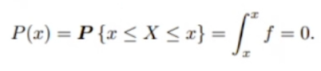

Example:

* The lifetime, in years, of some electronic component is a continuous random variable with the density:
  + A picture containing graphical user interface

    Description automatically generated
* Find k, draw a graph of the cdf F(x), and compute the probability for the lifetime to exceed 5 years.
* ---
* Text, letter

  Description automatically generated
* All area under the curve is supposed to be 1 bc probability density function, if we sum all values, it will cover all outcomes and now it will be probability of the sample space.
* A picture containing diagram

  Description automatically generated
* Since our cumulative function starts from 1, so we want to use the F(5) which means x to be less than 5.
* Area under cdf is 1.

Expectation

Example is about discrete expectation.

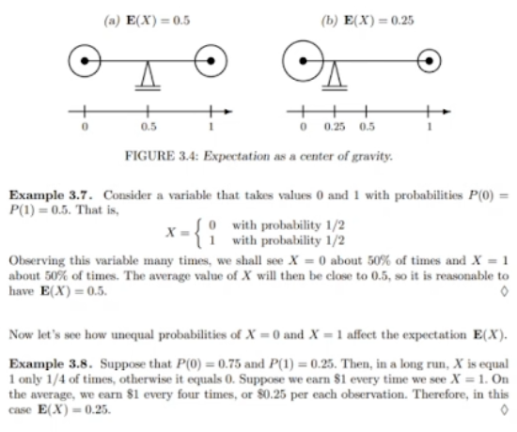

probability

In continuous:

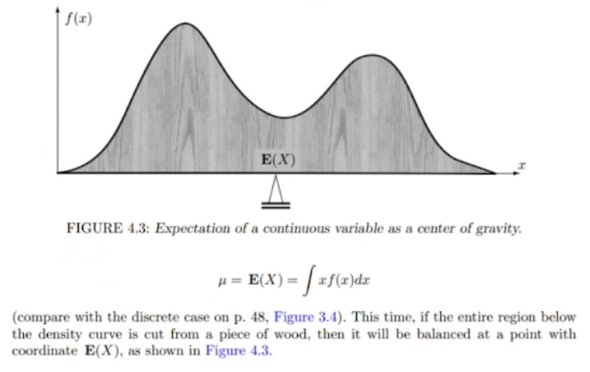

Example:

Uniform Distribution

***The Uniform Property:***

***Standard Uniform Distribution***

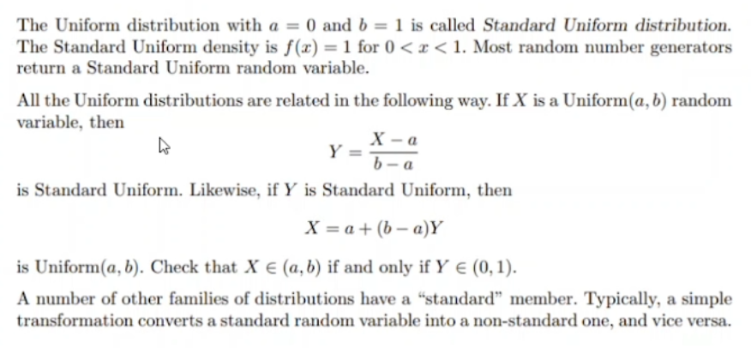

***Expectation and Variance***

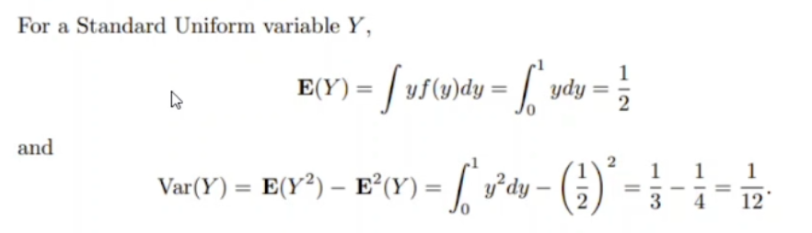

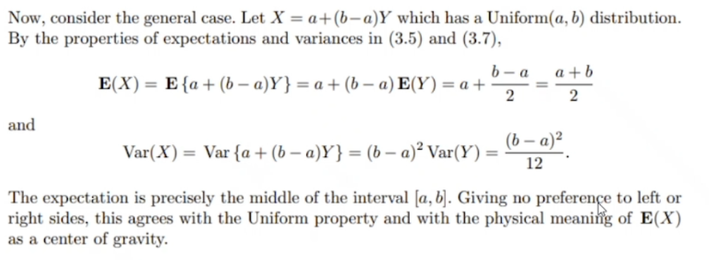

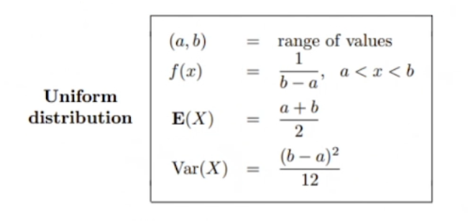

Exponential Distribution

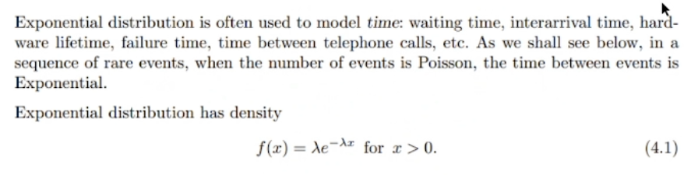

Lambda is frequency

x is usually time between 2 events

Rare event 🡪 2 events unlikely to occur simultaneously or within a very short period of time. Probability is low and time between 2 events is high.

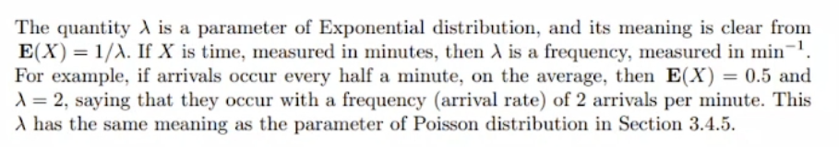

***RECALL***

***Times between rare events are exponential***

Example:

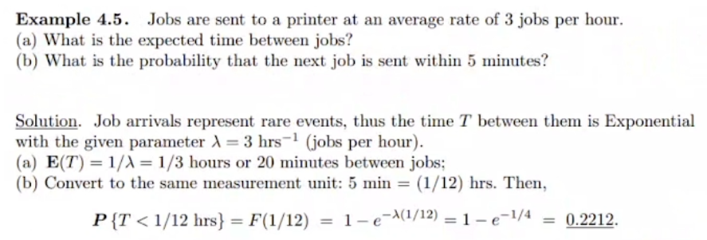

Memoryless Distribution

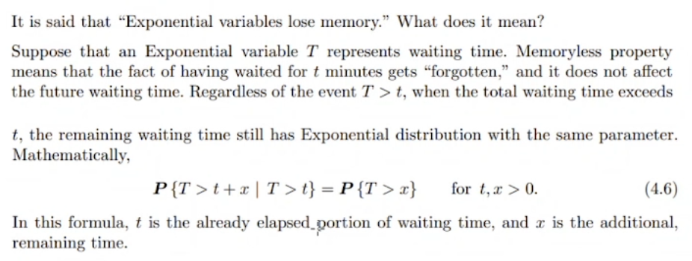

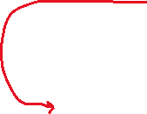

We forget the past before a time.

t süre geçmiş, x süre daha beklenecek. It forgets what happened until t.

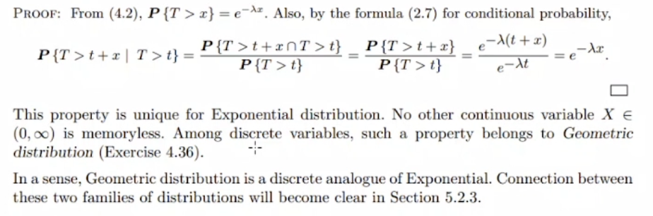



We carry some information from past which is lambda.

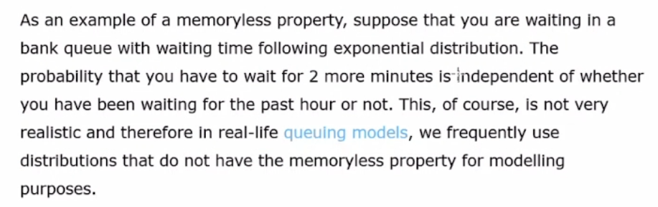

Each time you toss is independent from previous tosses.

***Binomial discrete example:***

X : number of person hired

